**TRANSLATION MUSIC**

**https://24x7offshoring.com/**

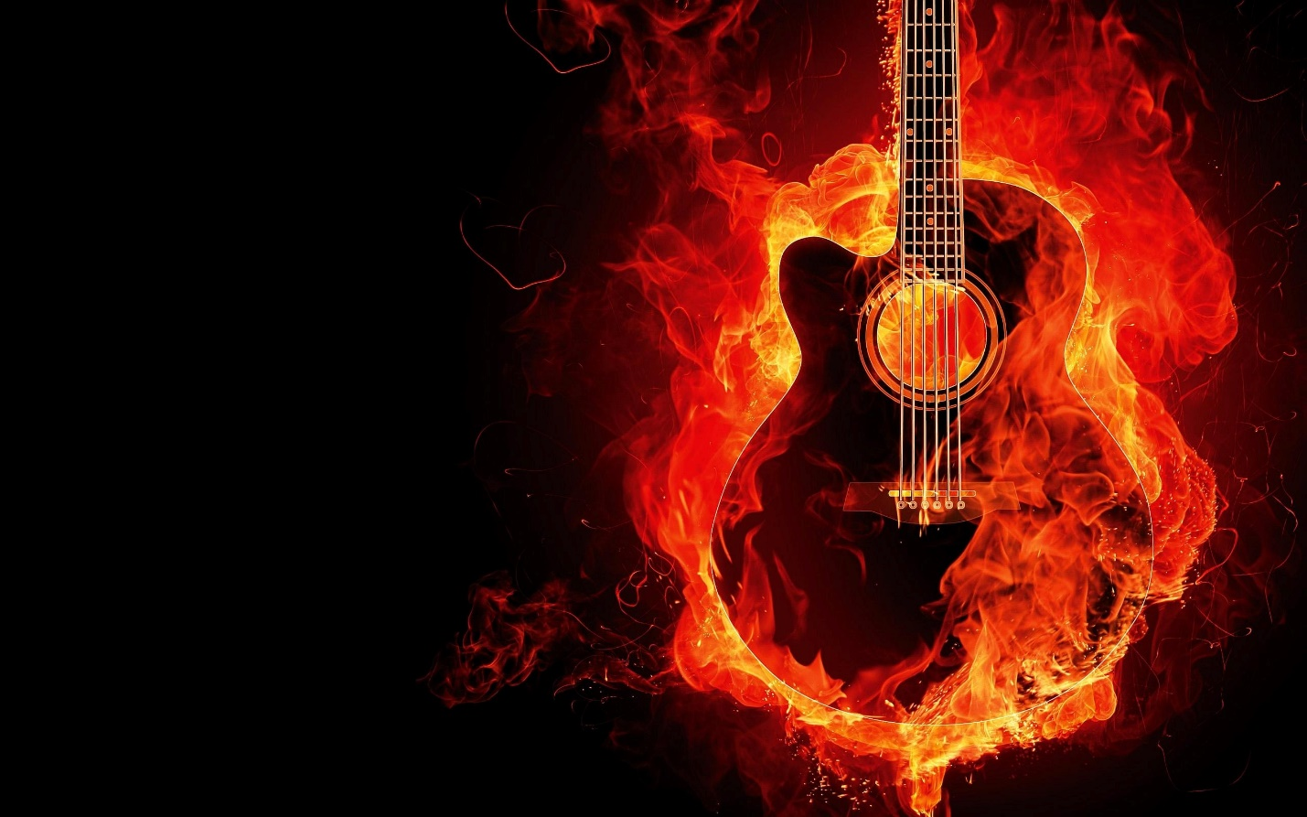 [**http://24x7outsourcing.com/**](http://24x7outsourcing.com/)

**Essential Words in Music Translation**

In this time of quick financial turn of events, numerous individuals are getting more extravagant and they are not substance with material pursuit any more.

An ever increasing number of individuals start to look for a profound life. Music craftsmanship is delighted in well-known help among individuals; particularly the lovely film tunes have empowered individuals' energy for music.

Other than this, different instruments become well known and chic in individuals' day by day life.

They desire to play the instruments and permitted the sweet music to be introduced. Because of these variables, they are anxious to find out about fundamental hypothesis information and social foundation of music.

Be that as it may, most western music related information is written in English. Along these lines, it is needed to be converted into Chinese.

Since the general public has such sort of interest, the interpreters should bear the duty of being a scaffold between individuals and the English papers.

Music interpretation is a unique part in regard of arrangements of interpretation.

It additionally has a few highlights. Presently I'd prefer to discuss the essential words in music interpretation.

**Peruse Also: The Translations for Some Musical Terms**

Melodic jargon is intriguing, some of them are normal words we acquainted with, yet they have unique implications in music.

To recognize various implications, I show whatever sort of words in the accompanying (note: the primary, the second and the third sections are the English word, the regular importance and the expert significance in music separately).

**Meter** 米 拍子 **section** 文章 乐段 **design** 模式 音型 **beat** 拍打 拍子 **quality** 质量 音质

**Span** 持续 时值 **second** 第二 二度 **staff** 员工 谱表 **stretch** 间隔 音程 **key** 关键 调

**Level** 平地 降号 **sharp** 尖头 升号 **regular** 自然的 还原 **major** 主要的 大调 **minor** 次要的 小调

**Bar** 条 小节 **time** 时间 拍子 **measure** 测量 小节 **esteem** 价值 时值 **rest** 休息 休止符

**Tie** 领带 延音线 **slur** 污点 连音线 **wind** 风 管乐器 **scale** 刻度 音阶 **step** 步骤 音程，度

…

**Coming up next are some regular melodic terms:**

**Pl. Neums** 纽姆谱 **rhythm** 节奏 **elements** 力度 **duple** 二拍子

**Triple** 三拍子 **fortissimo** 最强音的 **pianissimo** 最弱音的 **crescendo** 渐强

**Diminished** 渐弱 **timbre** 音色 **beat** 速度 **metronome** 节拍器

**Adagio** 慢板 **Andante** 行板 **Moderato** 中板 **Allegretto** 小快板

**Allegro** 快板 **Presto** 急板 **key mark** 调号 **timing scheme** 拍号

**Semibreve** 全音符 **quaver**八分音符 **semiquaver**十六分音符 **minim**二分音符

**Crotchet** 四分音符 **staccato** 跳音

**TRANSLATION MUSIC**

**https://24x7offshoring.com/**

**http://24x7outsourcing.com/**